**Showing conditional records into a new table**

While creating a **new table** Filter function can be used to conditionally show records from existing table into that new table.

**UAE_Data = Filter(Asia, Asia[Country] = "UAE")**

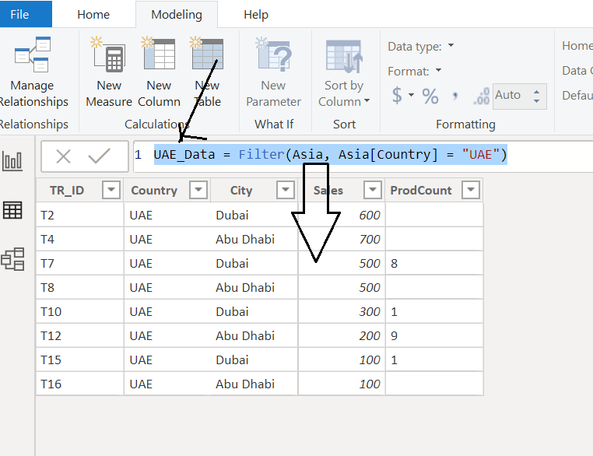

**Creating a table without one column**

**UAE_Data2 = Filter(ALLEXCEPT(Asia,Asia[TR_ID]), Asia[Country] = "UAE")**

**Creating a table without multiple columns**

**UAE_Data3 = Filter(ALLEXCEPT(Asia, Asia[TR_ID], Asia[ProdCount]),Asia[Country] = "UAE")**